Little R’s
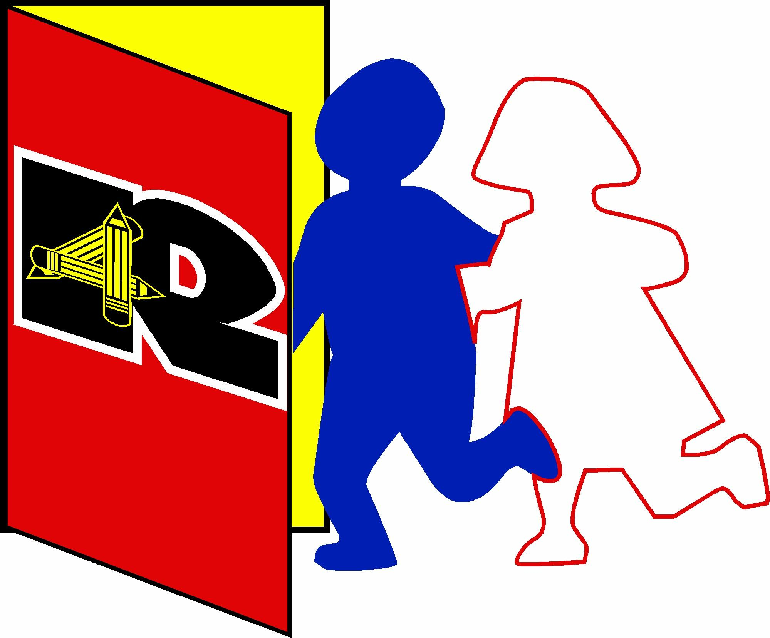
Pre-school

- fun activities
- education based
- highly qualified teachers
- happy, safe environment
- individual feedback

- low child/adult ratio

Prepare for Kindergarten
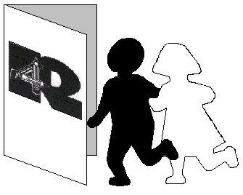
Little R’s
Pre-school


Little R’s Pre-school is a division of 4R’s Education Centre (Soc.), providing a safe, nurturing and active learning environment that will aid the social, emotional, intellectual and physical growth of each child. An active learning environment consists of age appropriate “hands-on” materials, supportive adult-child interaction, and a creative, well-planned, consistent, yet flexible, daily routine. This approach will enable young children to learn concepts, form ideas and develop an awareness of their world and their own unique learning style through play. Pre-school curriculum is designed to prepare your child for life-long learning.

Goals of the Preschool are:
- To facilitate in developing a healthy sense of self and others.
- To provide activities that will challenge growth in all areas of development.
- To aid in developing a strong foundation for future success in education.

Licenced Facility # TMGN-8K7ME2
Phone: 250-338-4890

Email: four.rs@shaw.ca

